# **VEHICLE TRACHING USING DRIVER MOBILE GPS TRACKING**

**Presented By:**

1)GUBBA JAGADEESH (2203031240439)

2)TARUN KUMAR ()

3)HARSHA()

4)TEJA()

**Guided By:** Yousuf sk

AI & AIDS Department PIET, Parul University

# **Introduction**

**Objective:**

Vehicle tracking refers to the process of monitoring the location and movement of a vehicle in real-time using GPS (Global Positioning System) technology. It is primarily used for fleet management, logistics, and personal vehicle monitoring. Through the use of GPS tracking devices, which are installed in vehicles, users can track the vehicle's position, speed, and route on a digital map.

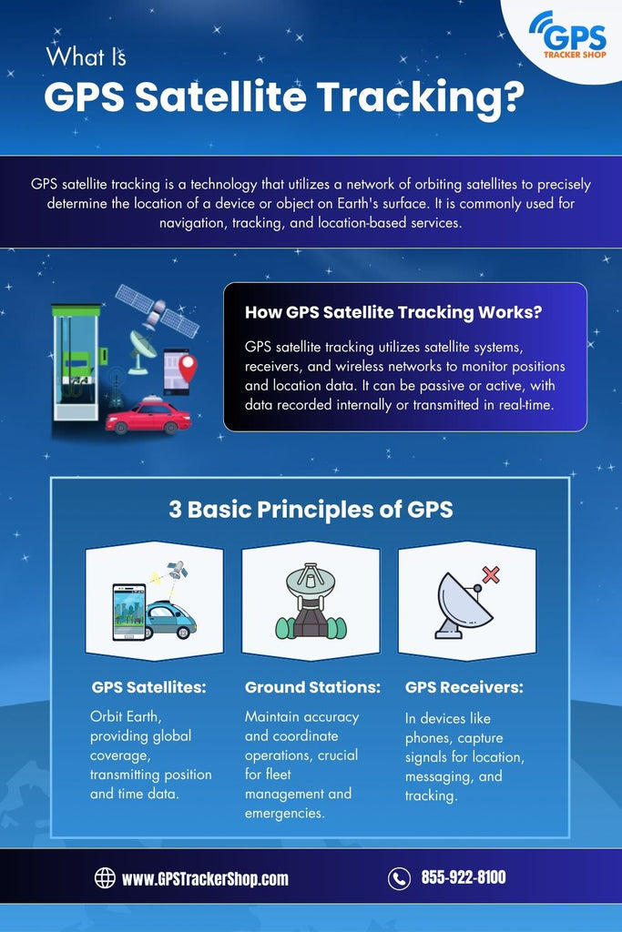01 Vehicle tracking involves using GPS technology to monitor the  
location and movements of vehicles in real-time.  
02 GPS tracking enhances fleet management, improves safety, andincrease operational efficiency.

**Benefits of Mobile GPS Tracking:**

01 Fleet managers can track vehicles in real-time, ensuring timelydeliveries and route optimization.  
02 GPS tracking helps in monitoring driver behavior, reducingaccidents and enhancing safety.  
03 By optimizing routes and reducing fuel consumption, businessescan save significantly.  
04 Drivers are more accountable for their actions when they knowthey are being monitored

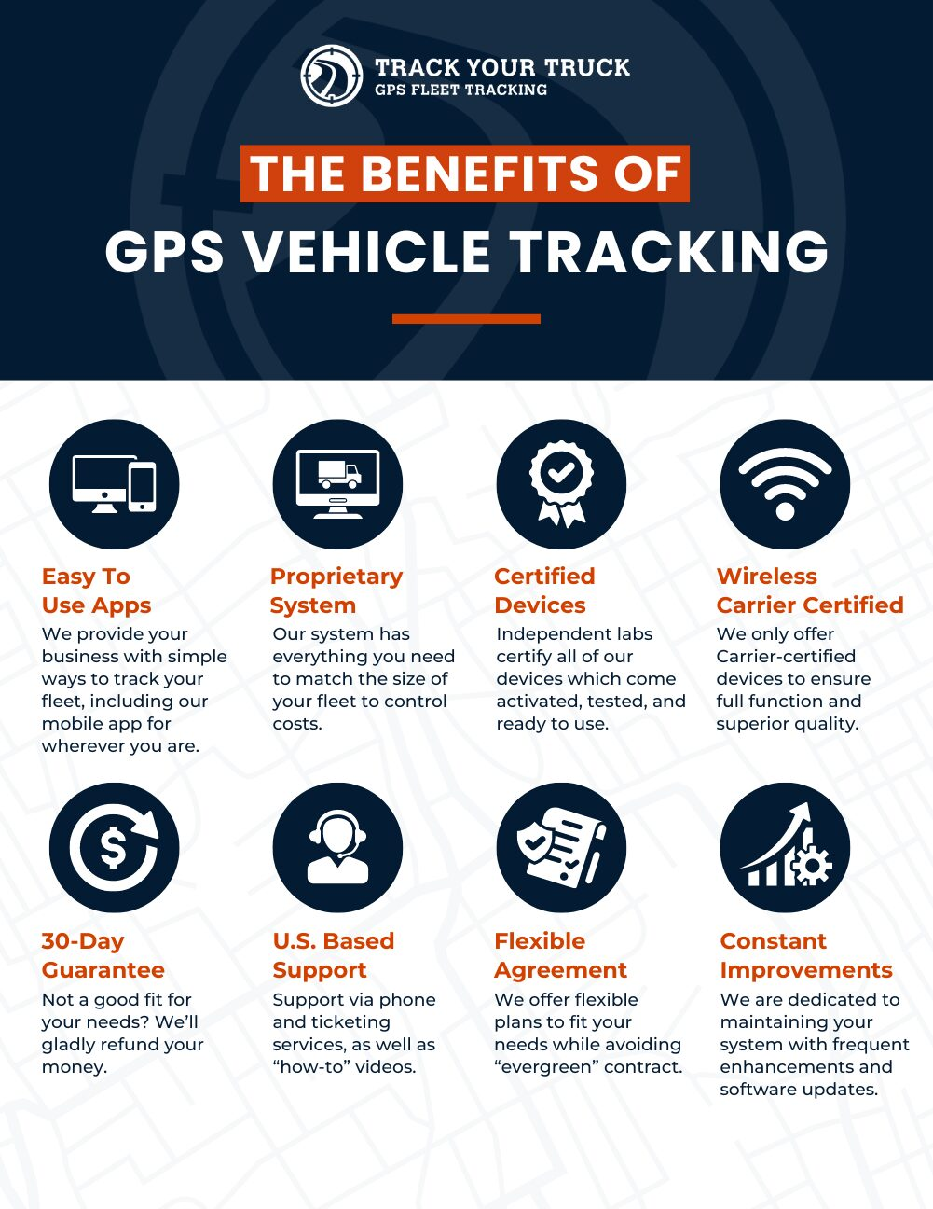

FLOW CHART :

Creating a flow chart for a vehicle tracking system that uses a driver’s mobile GPS involves outlining key stages and processes. Here's a basic flow chart structure:

+-------------------------+

| Start |

+-------------------------+

|

v

+-------------------------+

| Driver Mobile GPS |

| Tracking Activated |

+-------------------------+

|

v

+-------------------------+

| Data Sent to Tracking |

| Server (Location Data) |

+-------------------------+

|

v

+-------------------------+

| Server Receives GPS |

| Data |

+-------------------------+

|

v

+-------------------------+

| Display Location on |

| Tracking Interface |

+-------------------------+

|

v

+-------------------------+

| Vehicle Location |

| Update Interval |

+-------------------------+

|

v

+-------------------------+

| Event Triggers |

| (Optional Alerts) |

+-------------------------+

|

v

+-------------------------+

| Data Storage & History |

| (Optional) |

+-------------------------+

|

v

+-------------------------+

| User Notifications |

| (Optional Alerts) |

+-------------------------+

|

v

+-------------------------+

| End |

+-------------------------+

**Key Features of Driver Mobile GPS Tracking:**

01 Access to real-time location data for all vehicles in the fleet.  
02 Set virtual boundaries and receive alerts when vehicles enter or exit designated areas.  
03 Track speeding, harsh braking, and other driving habits to improve safety.  
04 Review past trips and performance metrics to identify areas for improvement.

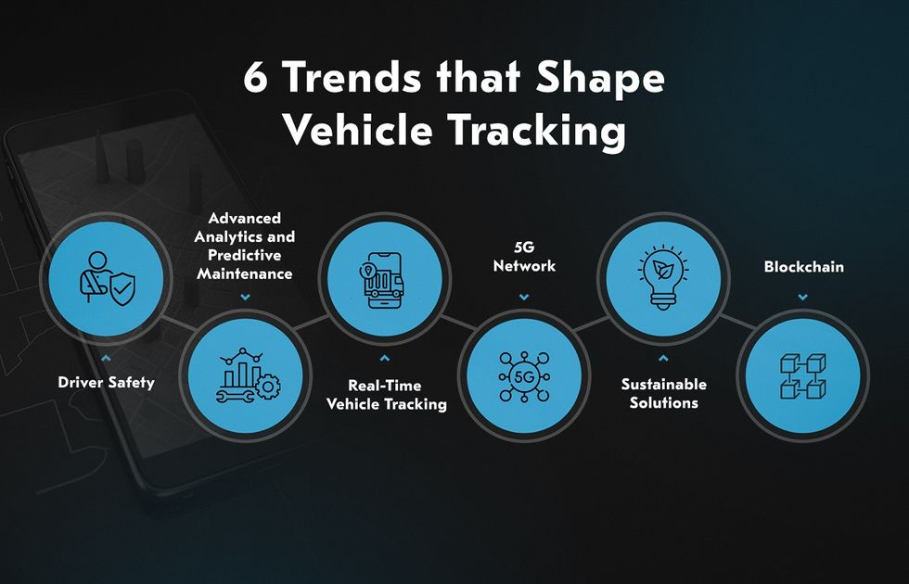

**Implementing a GPS Tracking System:**

01 Identify specific requirements and goals for your tracking system.  
02 Select GPS devices and software that fit your operational needs.  
03 Ensure that all users are trained on how to use the system  
effectively.  
04 Continuously evaluate the system's performance and make  
necessary adjustments

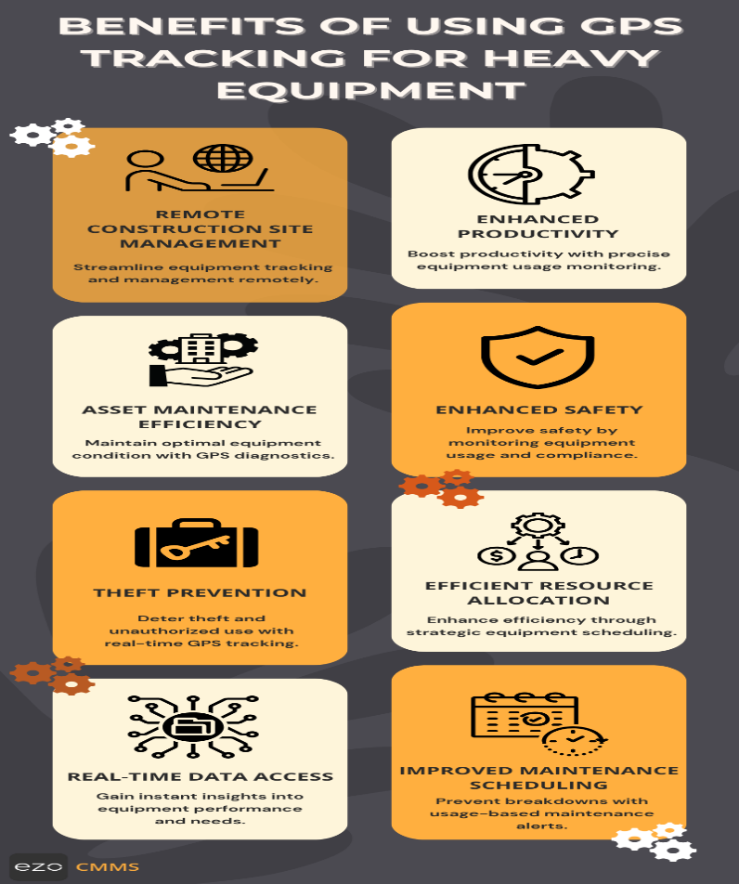

**REFERENCE** :

A vehicle tracking system (VTS) refers to a technology that allows the real-time tracking and monitoring of vehicles through GPS (Global Positioning System) or RFID (Radio Frequency Identification) technology. It typically uses a combination of hardware (such as GPS devices) and software to monitor, control, and manage the movements of vehicles. These systems are widely used in fleet management, logistics, transportation, and personal vehicle monitoring.

* **GPS Receiver**: Collects location data (latitude, longitude).
* **Telematics Unit**: Monitors vehicle data (speed, fuel consumption, etc.).
* **Communication Module**: Sends data via cellular or satellite communication.
* **Tracking Software**: Displays and analyzes data on a web/mobile app.

**Conclusion:**

01 Adopting mobile GPS tracking is essential for modern fleet  
management.  
02 Stay ahead of the competition by leveraging the latest tracking  
technologies.  
03 Prioritize safety and efficiency through effective tracking  
solutions.  
04 Explore new possibilities as technology continues to evolve

